26.21: a) The sum of the currents that enter the junction below the 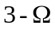 resistor equals
3.00 A + 5.00 A = 8.00 A.
b) Using the lower left loop:
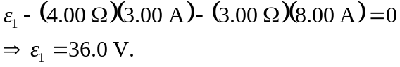
Using the lower right loop:
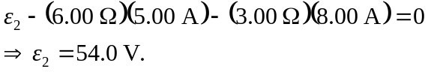
c) Using the top loop:
